PROTOCOL FOR USERS BD FACSCELESTA SORP

**START UP (30 minutes before running your experiment)**

**FLUIDIC SYSTEM (trolley)**

* Check FACS sheath volume and the waste container.
* Remove pressure from waste container: unscrew and screw back the lid.
* Switch on the fluidic system (trolley).
* Bubbles? Press Prime for 2 seconds.

**CYTOMETER**

* Switch on.
* Check that SETUP is in HTS mode (even if you are running tubes).
  + Not correct? Press MODE, choose HTS, and press UP. Then exit (MODE / EXIT / UP).
* Fine adjustment: 250.
  + Low 12 µl/minute.
  + Medium 30 µl/minute.
  + High 60 µl/minute.
* Leave the cytometer in STANBY for 30 minutes.

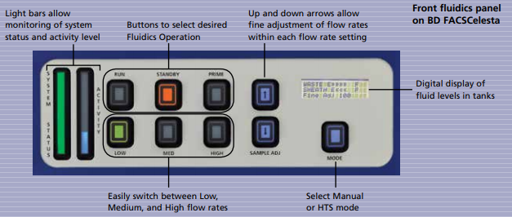

**COMPUTER**

* Switch on (password: BDIS#1).
* Open DIVA (create your user so you export your “.fcs” files in separate folders).
* It connects automatically (check window Cytometer to say “Cytometer Connected”
* Purge fluidic system (x2): move support of the tube to the side, press PRIME. Observe bubbling. It should appear STANDBY.
* Perform quality control (CST).
* Press “Use CST Settings”.

**RUNNING YOUR SAMPLES**

**CHANGE CONTAINERS OF THE FLUIDIC SYSTEM**

* Sheat empty
  + Press ALARM (switch off the noise) + press STANDBY.
  + Leave sensor in the holder (on the side).
  + Change container.
  + Press RESTART (light of FACSFlow should switch off).
* Waste full
  + Press ALARM (switch off the noise) + press STANDBY.
  + Leave sensor in 500 mL diluted water (10%).
  + Press RESTART (light of FACSFlow should switch off).

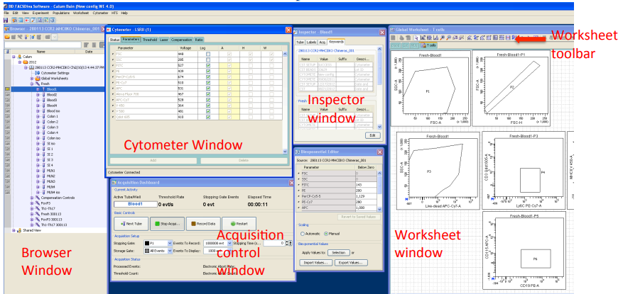

**FINISHING UP**

**EXPORT FILES**

* Export “.fcs” files – press RIGHT BUTTON on your experiment / EXPORT FCS FILES.
* Transfer files from the desktop (Shorcut to .fcs files) and transfer to your database.
* Files will be deleted every two months.

**CLEAN THE CYTOMETER**

* Open the file CLEAN
* Each step is 5’ in RUN and HI.
  + FACS Clean: Open the support for 1’. Then close, and leave 5’. If using tissues, use CONTRAD.
  + FACS Rinse.
  + Distilled water.
* **Important:** if using chemicals like ethidium bromide, Hoechst, DAPI, propidium iodide, please add 3 mL ethanol 70% before FACS Clean.
* Check less than 50 events / sample appear on the plot (press RESTART and check for 1’).
* Press STANDBY

**SWITCH OFF INSTRUMENTS**

* Close FACS DIVA and switch off computer.
* Switch off cytometer.
* Switch off fluidic system.

**ANALYZING YOUR SAMPLES**

* Create incidence in Acomsis to ask for USB stick.
* Sign in the list in the informatician office.
* Use it in the computer analysis.
* Return the USB stick. Sign in again in the list – if the informatician office is closed, ask the caretaker to open you the office.